**OPEN AI CODE LIKE GENERATIVE AI**

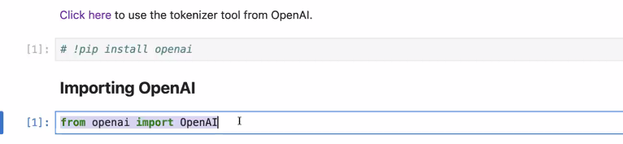

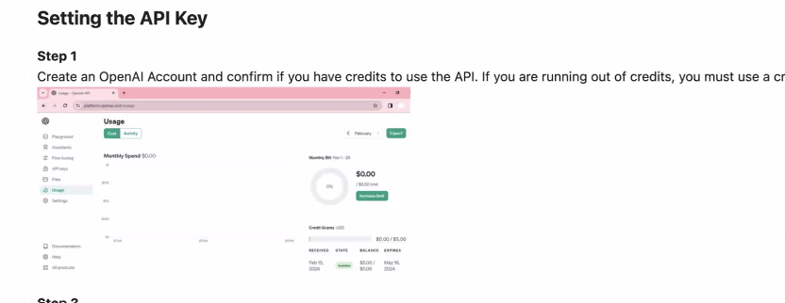

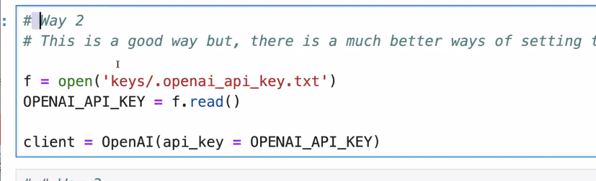

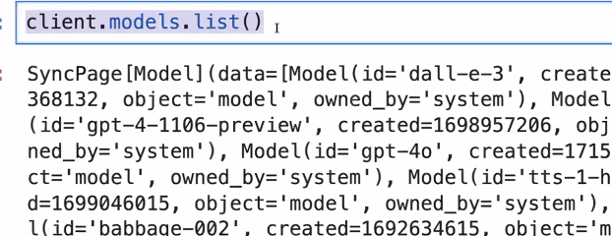

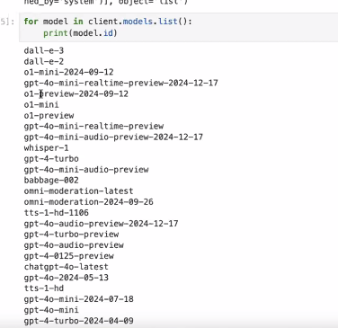

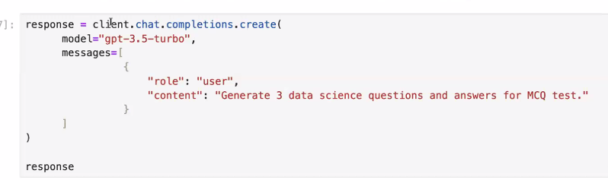

**SYSTEM ADMIN OPTION ON OPEN AI**

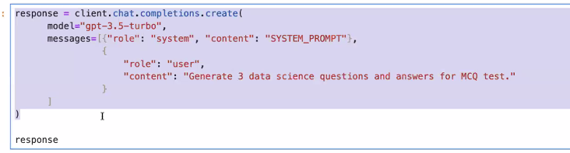

**PRINITING RESPONSE OF OPEN AI**

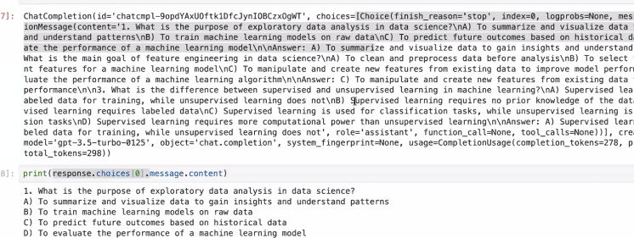

**EXAMPLE FOR IMAGE MODEL**

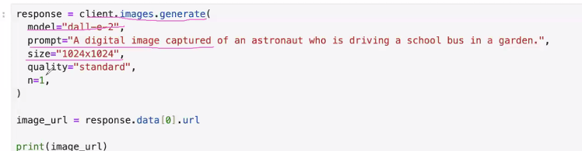

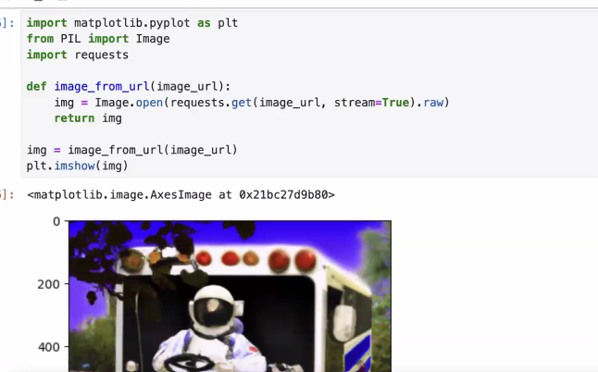

**ABOUT HUGGING FACE**

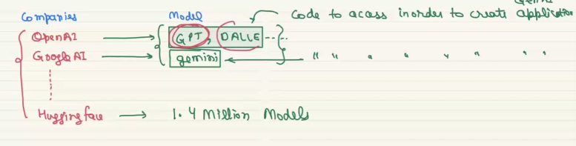

**ABOUT LANG CHAIN**

Helps to switch from one model to another model with minimal no of changes

EX: if we want to change gemini model to open ai the configuration for both are different, but with the help of lang chain we can do this is in simple way.

Normal chat gpt website is called single term application, we can give only one message and it gives only one response, A multi turn version will have 2 or more input and output, for this lang chain is also used

It is a framework for model development.

**PROMPT ENGINEERING**

It is a study of designing the input for model

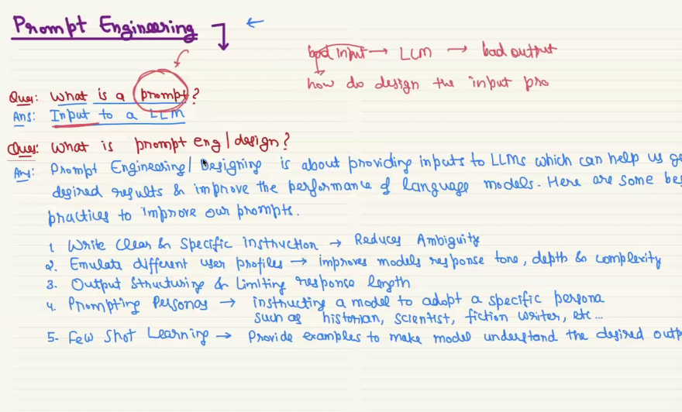

**Example for confusing input:**

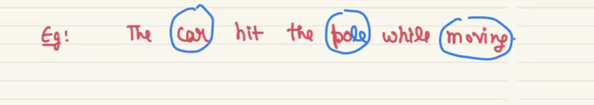

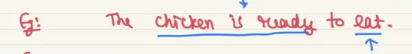

**Example for emulate different user profile in user prompt:**

This is also one way of designing the prompt

1. Assume iam a 10 year old kid to explain this concept
2. Just skip the basic part I am clg student so give me the important points to write it on my exam.

**Example for output structing and limiting:**

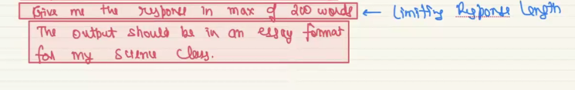

**Example for all 4 prompt design**

